Bidirectional Visitor Counter

Gaurav Bhaltilak, Prasad Gangurde ,Rohit Chauhan

*Second Year Electronics and Telecommunication , VIIT Pune  
Address*

[gaurav.22210425@viit.ac.in](mailto:gaurav.22210425@viit.ac.in)

[rohit.22210640@viit.ac.in](mailto:rohit.22210640@viit.ac.in)

[prasad.22210275@viit.ac.in](mailto:prasad.22210275@viit.ac.in)

***Abstract*-In this project, we are going to build an embedded system that can be used to count the total number of people entering through the gate and also the total number of people leaving through the same gate. And finally, it counts the total number of people currently present inside the room .** **When somebody enters the room then the counter is incremented by one (+1) and when any one leaves the room then the counter is decremented by one (-1). The total number of persons inside the room is also displayed on the LCD (Liquid Crystal Display).**

***Keywords--*Bidirectional visitor counter, IR Sensors, Microcontroller, Liquid Crystal Display and Circuit.**

1. **Introduction**

The main purpose of this paper is to tell that We have designed a project to get the count of the people when they enter they enter the hall and when they exit the hall . we can maintain the flow of crowd. We are using a 8051 micro controller which is used to give commands to the components to complete the process . So to insert code into a micro controller we typed the code in the keil software the converted the keil file to hex file. After getting the hex file we can insert it into the micro controller so that it can perform the functions. After setting up the code then when the person enters the walk way we will be having two pairs of IR transmitter - receiver pair which help to get the count of the person when there is an interruption of rays between the transmitter and receiver . so through the ports if there is an interruption we will get the count on the LCD screen of the people entering and exiting the hall or a room .

1. **SOFTWARE DESCRIPTION**

* Keil IDE
* Proteus
* Progisp

1. **HARDWARE DESCPRITION**

* AT89C51 Microcontroller
* 2 x IR Sensors
* 16x2 LCD Display

1. MICROCONTROLLER : It is a compressed micro computer manufactured to control the functions which can be done in embedded systems like in robots , home appliances , motor vehicles .

The key features of micro controllers include:

•High Integration of Functionality , Field Programmability , Flexibility .

• Easy to Use Assembly language is often used in micro controllers and since they usually follow RISC architecture, the instruction set is small. It is a single chip micro controller which is made through VLSI fabrication Some packages include a high level language compiler such as a C compiler and more sophisticated libraries.

1. IR Sensors : This is the main component which we have used in the circuit if there is any disturbance caused between the beam of light at the receiving end

then it considers as the person as entered .

1. LCD Display : LCD means liquid crystal display . it works by applying a varying voltage to layer of liquid crystal . It is often used in battery powered electronic devices because it require small amount of electric power . Common display have 16 t0 20 character and 1 to 4 lines. In this visitor counter project we have used this component to display the amount of people in the room . it also displays if the person exits and enters the hall.

BLOCK DIAGRAM

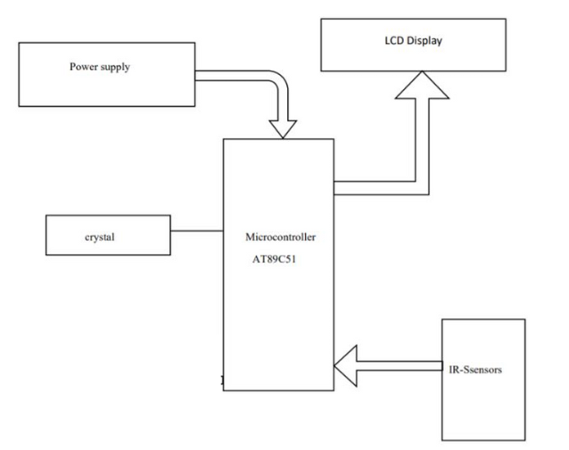

**WORKING DISCRIPTION**

In this project, bidirectional visitor counter system is developed using 8051 microcontroller. The main component of the project is IR Sensor and we have used two of them. The placement of the sensors is important as it will determine the functioning of the project. Both the sensors must be placed on the either side of the door or entrance of the room. The sensor placed on the outside of the room is named as Sensor 1 and the sensor, which is placed on the inside is named Sensor 2. When a person tries to enter the room, Sensor 1 detects the person first and then Sensor 2. This action will indicate the 8051 Microcontroller that the person is entering the room. Hence, the microcontroller will increments the visitor counter to 1. If there are more visitor, increments the visitor counter accordingly. When a person tries to leave the room, Sensor 2 detects the person first and then Sensor 1. This process will make the microcontroller to understand that a person is trying to leave the room and hence, it will decrement the count of visitors. As the visitors start leaving the room, the visitor count will be decremented . After setting up the code then when the person enters the walk way we will be having two pairs of IR transmitter - receiver pair which help to get the count of the person when there is an interruption of rays between the transmitter and receiver . so through the ports if there is an interruption we will get the count on the LCD screen of the people entering and exiting the hall or a room .

Flowchart :

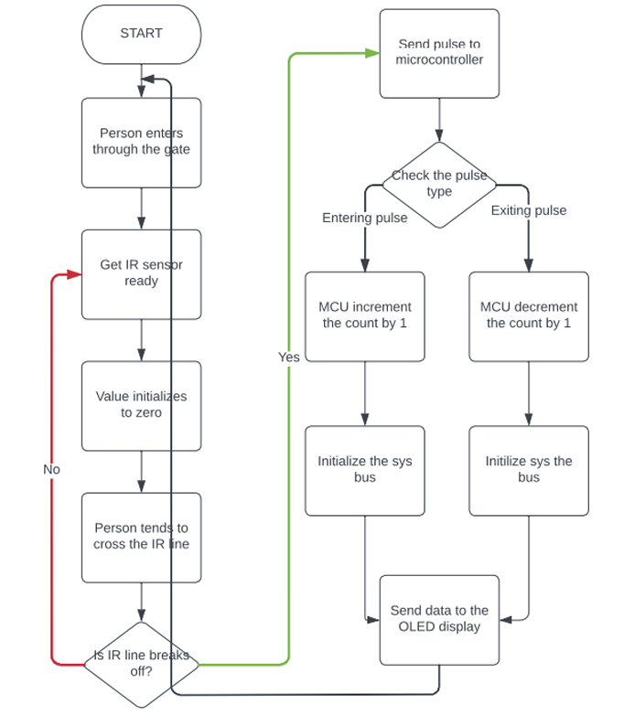

ROBLEMS IN REAL TIME SCENARIO: This is a very basic circuit and has few shortcomings. For example, this system will not differentiate between a person and any other obstacle interrupting the sensors. This can count on one person at a time .it cant be used for large scale. Also, this is a short range system. For long range, we can use laser beam. For overcoming these and many other problems with this system, further improvements are being done. Cameras and processing is now being used to differentiate between different interruptions.

FUTURE SCOPE : It can be used for counting the number of visitors in public places like malls , offices etc.We can use long range laser beam for longer interruption detection range. We can also use seven segment displays for longer and brighter display. As there are two sensors placed at the entry and exit point this counts at both entrance and exit points .if there is ant interruption in the way of the sensor then it counts the visitors and their exit also in the similar way as there will be one more sensor at the exit point. Once the system is successfully installed we can see the count of the visitors on the screen . so this could be installed in a place where we need to manage the crowd and we want them to be counted .energy efficiency increases as a automated switch due to bi directional visitor counter. The system can be used at the entrance of a room to control the lights and other appliances. For e.g. when the number of people in the room is zero, the circuit can automatically switch off the power thus avoiding energy wastage. By this way resources will be used efficiently.

Conclusion : This project titled “Bidirectional Visitor Counter” helps us to measure the people entering and exiting from the path or ways. This project helps us to find the number of people present in the hall which will be displayed on the screen as we attached a LCD display. This is not only limited to the counting of entering and exiting people it also helps us to manage the flow of people throughout the location. The circuit may also be enhanced with a wide counting range of above three digits by modifying software section of the system. It can also be enhanced for long and accurate sensing range using a laser torch instead of IR transmission circuit. Thus the circuit can be used to monitor visitor flow in effective manner, where the visitors have to counted and controlled.

References

# MICROCONTROLLER BASED BI-DIRECTIONAL VISITORS COUNTER(By : ABDELRAHMAN ABDELSALAM)

BI-DIRECTIONAL VISITOR COUNTERS USING 8051 MICROCONTROLLER (Dhanabal.R*1, Somalaraju Chenchu Babu*2)

Design and Construction of a Bidirectional Digital Visitor Counter Winfred Adjardjah 1 George Essien 2 Hilary Ackar-Arthur 2

Bidirectional Visitors’ Counter with Automatic Room Light Controller Jabire, A. H., Suleiman H., Noku A. A., Adamu P. U., Tsoken, D. A., Agidike, L. O.

AUTOMATIC ROOM LIGHT CONTROLLER WITH BIDIRECTIONAL VISITOR COUNTER( Ms. AFIYA M RAJ Mr. ALWIN SAM Ms. ANSU RACHEL ISSAC Ms. KAVYA KRISHNAN. K Ms. SHARANYA. S)